**Assignment(1)**

**Class:BCA-III(Sem-V)**

**Subject:System Analysis and Design**

**Topics:**System and types of system,SDLC

**Submitted To:**

Preetima Garg

Prof.of Comp.Sci.Department

**Ques1:Definition of System and types of system?**

## Ans What is a System?

The word System is derived from Greek word Systema, which means an organized relationship between any set of components to achieve some common cause or objective.

A system is “an orderly grouping of interdependent components linked together according to a plan to achieve a specific goal.”

**Constraints of a System**

A system must have three basic constraints −

* A system must have some **structure and behavior** which is designed to achieve a predefined objective.
* **Interconnectivity** and **interdependence** must exist among the system components.
* The **objectives of the organization** have a **higher priority** than the objectives of its subsystems.

For example, traffic management system, payroll system, automatic library system, human resources information system.

## Types of Systems

The systems can be divided into the following types −

### Physical or Abstract Systems

* Physical systems are tangible entities. We can touch and feel them.
* Physical System may be static or dynamic in nature. For example, desks and chairs are the physical parts of computer center which are static. A programmed computer is a dynamic system in which programs, data, and applications can change according to the user's needs.
* Abstract systems are non-physical entities or conceptual that may be formulas, representation or model of a real system.

### Open or Closed Systems

* An open system must interact with its environment. It receives inputs from and delivers outputs to the outside of the system. For example, an information system which must adapt to the changing environmental conditions.
* A closed system does not interact with its environment. It is isolated from environmental influences. A completely closed system is rare in reality.

### Adaptive and Non Adaptive System

* Adaptive System responds to the change in the environment in a way to improve their performance and to survive. For example, human beings, animals.
* Non Adaptive System is the system which does not respond to the environment. For example, machines.

### Permanent or Temporary System

* Permanent System persists for long time. For example, business policies.
* Temporary System is made for specified time and after that they are demolished. For example, A DJ system is set up for a program and it is dissembled after the program.

### Natural and Manufactured System

* Natural systems are created by the nature. For example, Solar system, seasonal system.
* Manufactured System is the man-made system. For example, Rockets, dams, trains.

### Deterministic or Probabilistic System

* Deterministic system operates in a predictable manner and the interaction between system components is known with certainty. For example, two molecules of hydrogen and one molecule of oxygen makes water.
* Probabilistic System shows uncertain behavior. The exact output is not known. For example, Weather forecasting, mail delivery.

### Social, Human-Machine, Machine System

* Social System is made up of people. For example, social clubs, societies.
* In Human-Machine System, both human and machines are involved to perform a particular task. For example, Computer programming.
* Machine System is where human interference is neglected. All the tasks are performed by the machine. For example, an autonomous robot.

### Man–Made Information Systems

* It is an interconnected set of information resources to manage data for particular organization, under Direct Management Control (DMC).
* This system includes hardware, software, communication, data, and application for producing information according to the need of an organization.

Man-made information systems are divided into three types −

* **Formal Information System** − It is based on the flow of information in the form of memos, instructions, etc., from top level to lower levels of management.
* **Informal Information System** − This is employee based system which solves the day to day work related problems.
* **Computer Based System** − This system is directly dependent on the computer for managing business applications. For example, automatic library system, railway reservation system, banking system, etc.

**Ques2:Explain SDLC?**

**Ans.** An effective System Development Life Cycle (SDLC) should result in a high quality system that meets customer expectations, reaches completion within time and cost evaluations, and works effectively and efficiently in the current and planned Information Technology infrastructure.

System Development Life Cycle (SDLC) is a conceptual model which includes policies and procedures for developing or altering systems throughout their life cycles.

SDLC is used by analysts to develop an information system. SDLC includes the following activities −

* requirements
* design
* implementation
* testing
* deployment
* operations
* maintenance

Phases of SDLC

Systems Development Life Cycle is a systematic approach which explicitly breaks down the work into phases that are required to implement either new or modified Information System.

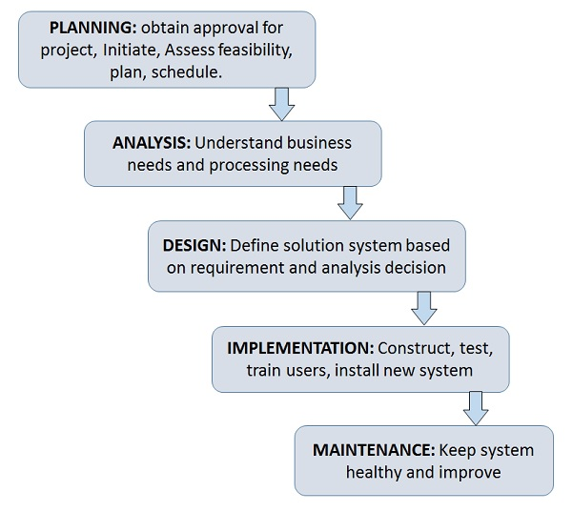

**Feasibility Study or Planning**

* Define the problem and scope of existing system.
* Overview the new system and determine its objectives.
* Confirm project feasibility and produce the project Schedule.
* During this phase, threats, constraints, integration and security of system are also considered.
* A feasibility report for the entire project is created at the end of this phase.

**Analysis and Specification**

* Gather, analyze, and validate the information.
* Define the requirements and prototypes for new system.
* Evaluate the alternatives and prioritize the requirements.
* Examine the information needs of end-user and enhances the system goal.
* A Software Requirement Specification (SRS) document, which specifies the software, hardware, functional, and network requirements of the system is prepared at the end of this phase.

**System Design**

* Includes the design of application, network, databases, user interfaces, and system interfaces.
* Transform the SRS document into logical structure, which contains detailed and complete set of specifications that can be implemented in a programming language.
* Create a contingency, training, maintenance, and operation plan.
* Review the proposed design. Ensure that the final design must meet the requirements stated in SRS document.
* Finally, prepare a design document which will be used during next phases.

**Implementation**

* Implement the design into source code through coding.
* Combine all the modules together into training environment that detects errors and defects.
* A test report which contains errors is prepared through test plan that includes test related tasks such as test case generation, testing criteria, and resource allocation for testing.
* Integrate the information system into its environment and install the new system.

**Maintenance/Support**

* Include all the activities such as phone support or physical on-site support for users that is required once the system is installing.
* Implement the changes that software might undergo over a period of time, or implement any new requirements after the software is deployed at the customer location.
* It also includes handling the residual errors and resolve any issues that may exist in the system even after the testing phase.
* Maintenance and support may be needed for a longer time for large systems and for a short time for smaller systems.